**DB tables creation:**

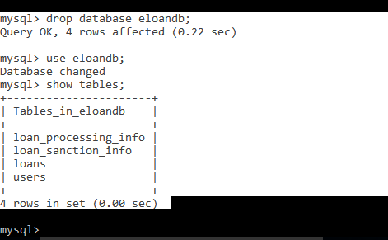

**Customer role-**

**Customer Registration:**

<http://localhost:9090/eloan-app/customer/register>

{

"firstName":"Rajesh",

"lastName":"Good",

"email":"goodrajesh@gmail.com",

"mobile":"8956895611",

"role":"customer"

}

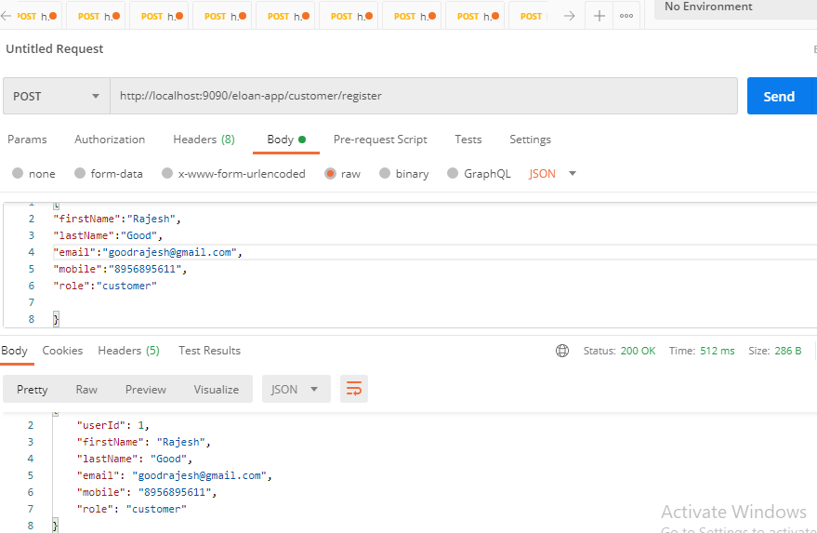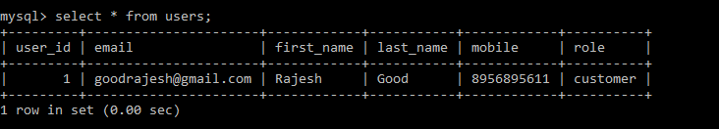

**Apply loan:**

<http://localhost:9090/eloan-app/customer/apply-loan/1>

{

    "loanName":"Home",

    "loanAmount":100000.0,

    "businessStructure":"Retail",

    "billingIndicator":"salaried",

    "taxIndicator":"tax-payer"

}

{

    "loanName":"Car",

    "loanAmount":100000.0,

    "businessStructure":"International",

    "billingIndicator":"salaried",

    "taxIndicator":"tax-payer"

}

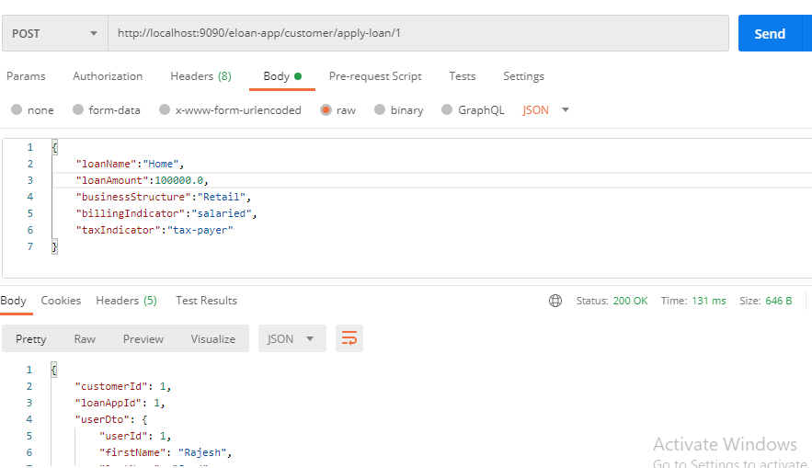

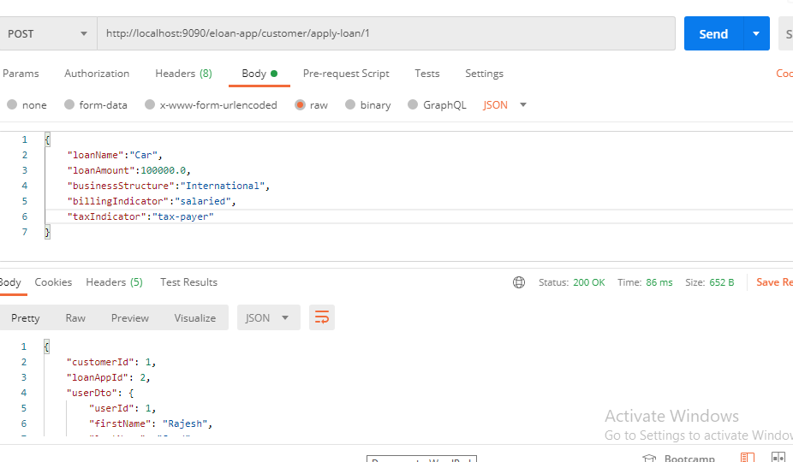

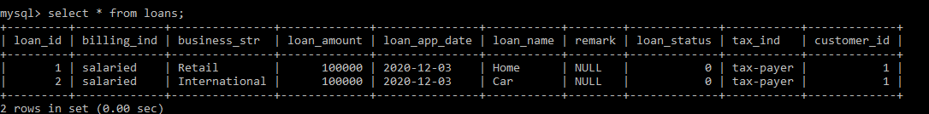

**Get-status:**

<http://localhost:9090/eloan-app/customer/loan-status/2>

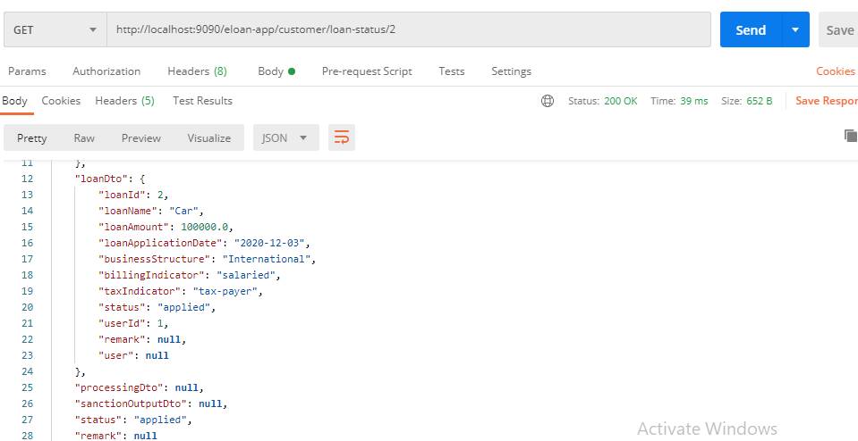

**Get all Loans Status:**

<http://localhost:9090/eloan-app/customer/loan-status-all/1>

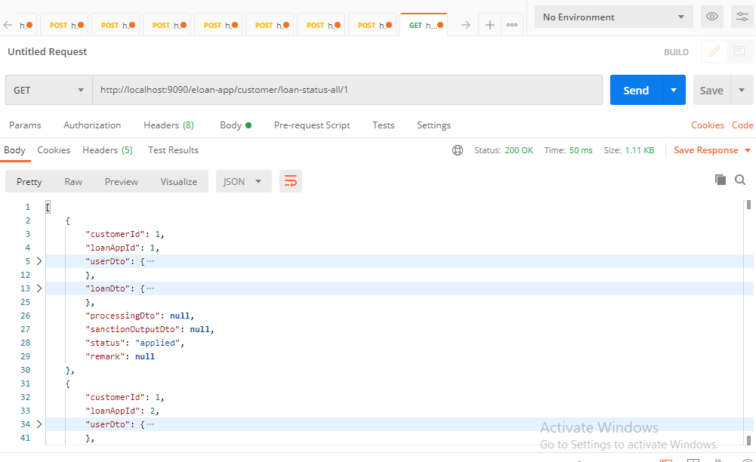

**Admin role:**

**Clerk registration:**

<http://localhost:9090/eloan-app/admin/register-clerk>

{

"firstName":"Clerk1",

"lastName":"Clerk1",

"email":"clerk@gmail.com",

"mobile":"8956895611",

"role":"clerk"

}

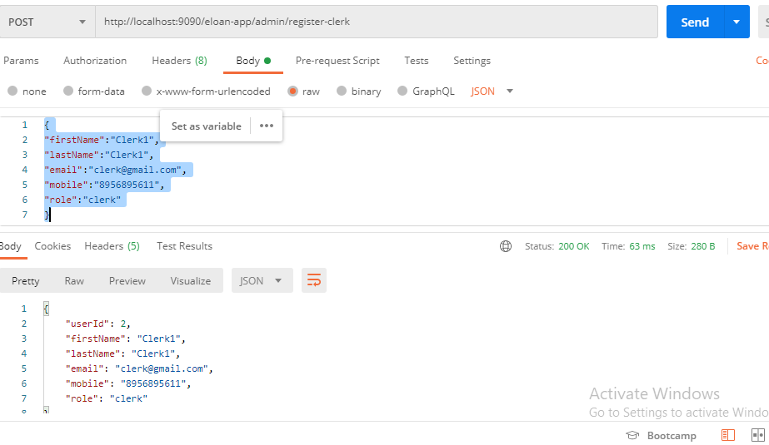

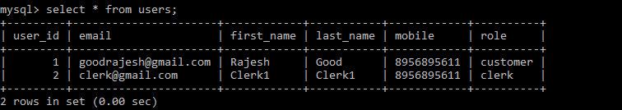

**Manager Registration:**

<http://localhost:9090/eloan-app/admin/register-manager>

{

"firstName":"Manager1",

"lastName":"Manager1",

"email":"manager@gmail.com",

"mobile":"8956895611",

"role":"manager"

}

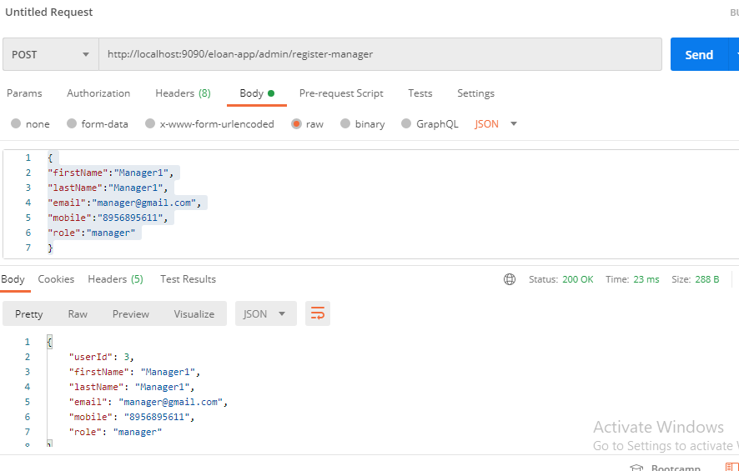

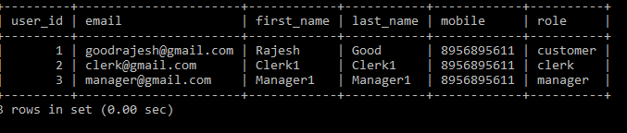

**Get all clerks:**

<http://localhost:9090/eloan-app/admin/all-clerks>

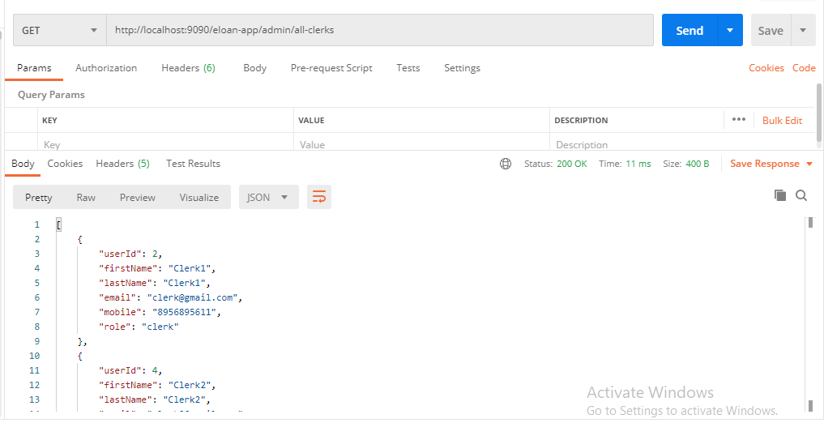

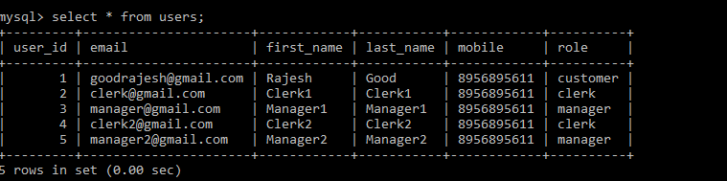

**Get all Managers:**

<http://localhost:9090/eloan-app/admin/all-managers>

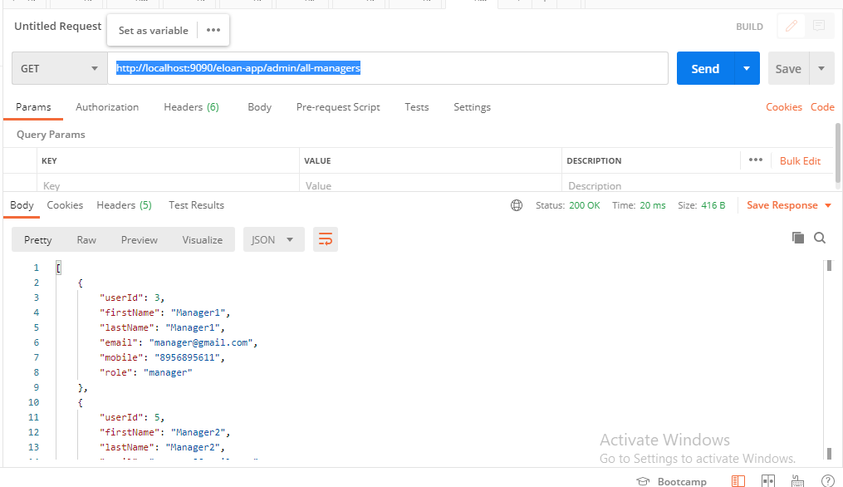

**Clerk roles:**

**Get all processed loans:**

<http://localhost:9090/eloan-app/clerk/all-applied>

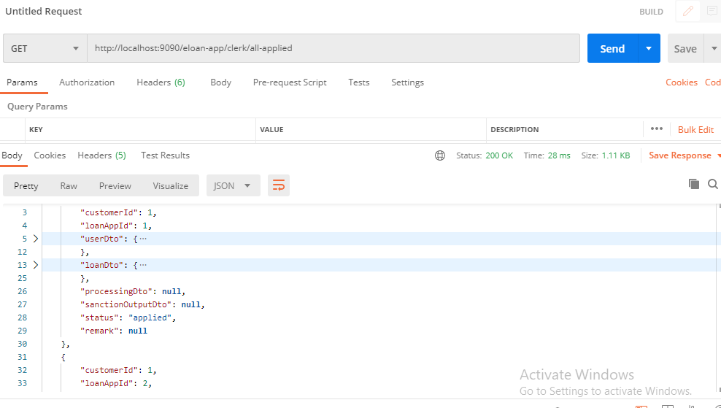

Process Loan:

<http://localhost:9090/eloan-app/clerk/process/2/2>

{

    "acresOfLand":20000000.0,

    "landValue":300000.0,

    "appraisedBy":"Appraiser Name1",

    "valuationDate":"2020-02-02",

    "addressOfProperty":"tax-payer address",

    "suggestedAmountOfLoan":1200000

}

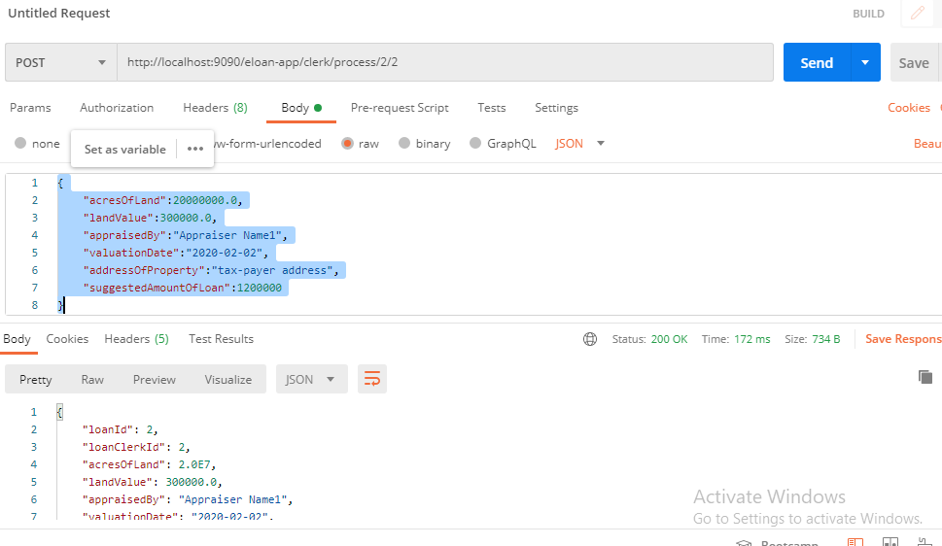

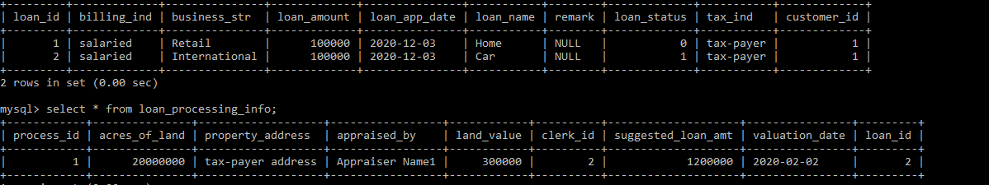

Manager roles:

Get all processed loans:

<http://localhost:9090/eloan-app/manager/all-processed>

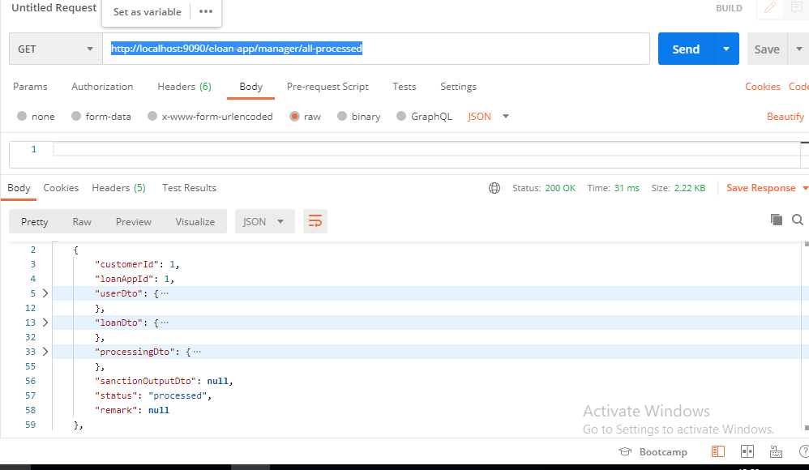

Reject loan:

<http://localhost:9090/eloan-app/manager/reject-loan/3/1>

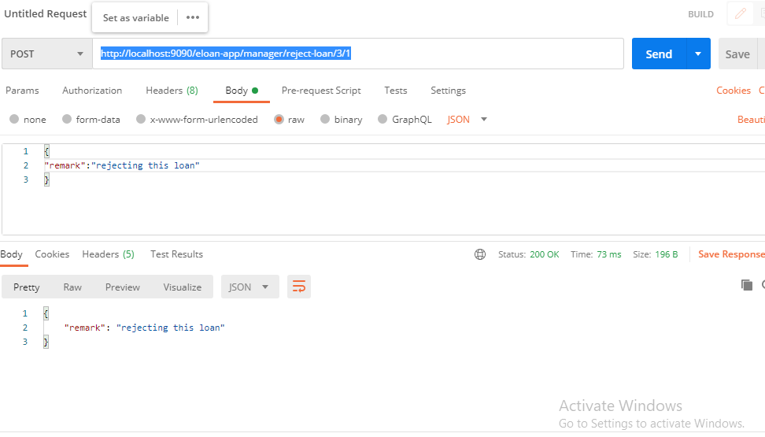



Sanction loan:

<http://localhost:9090/eloan-app/manager/sanction-loan/3/2>

{

"loanAmountSanctioned":10000,

"termOfLoan":12,

"paymentStartDate":"2020-02-02",

"remark":"test"

}

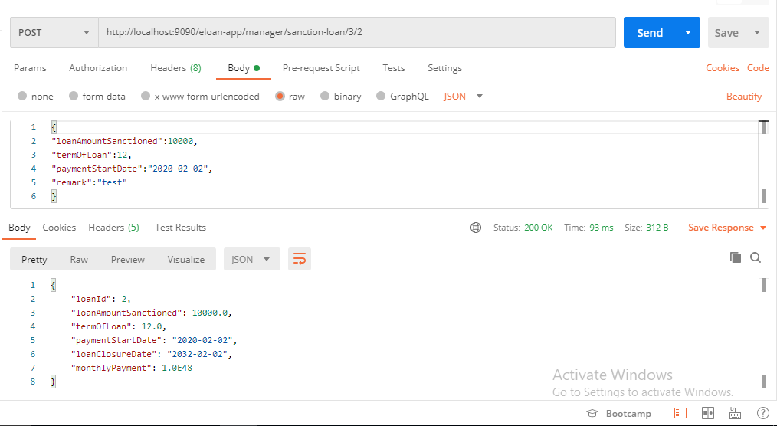

* While applying loan by customer, if customer id does not exist then operation should throw custom exception.

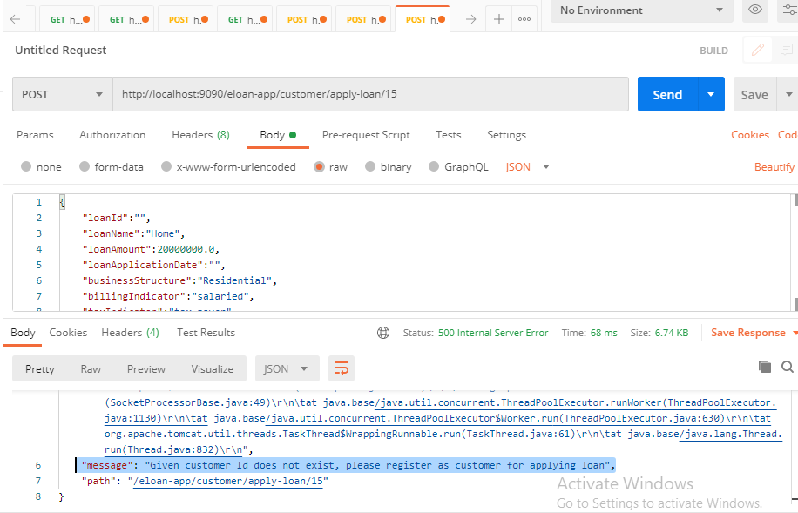

* While fetching loan status, if loan application id does not exist then operation should throw custom exception.

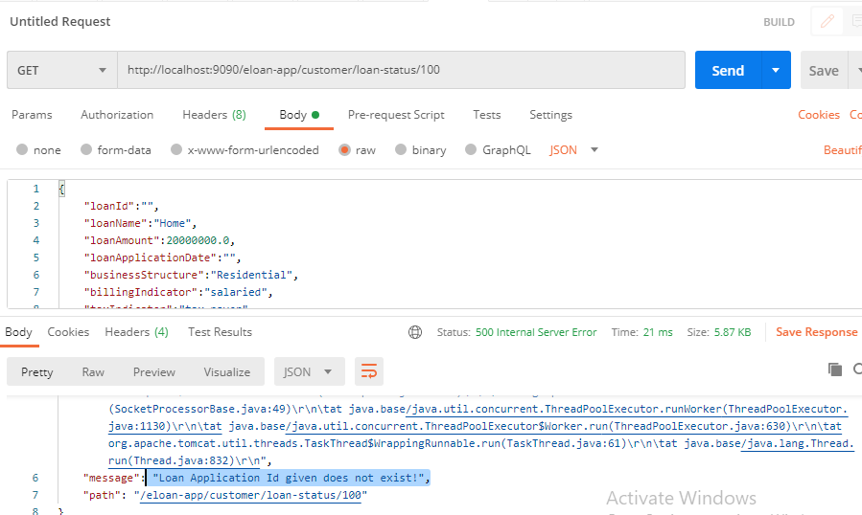

**Validations:**

While fetching all loan details of a customer, if customer id does not exist then operation should throw custom exception.

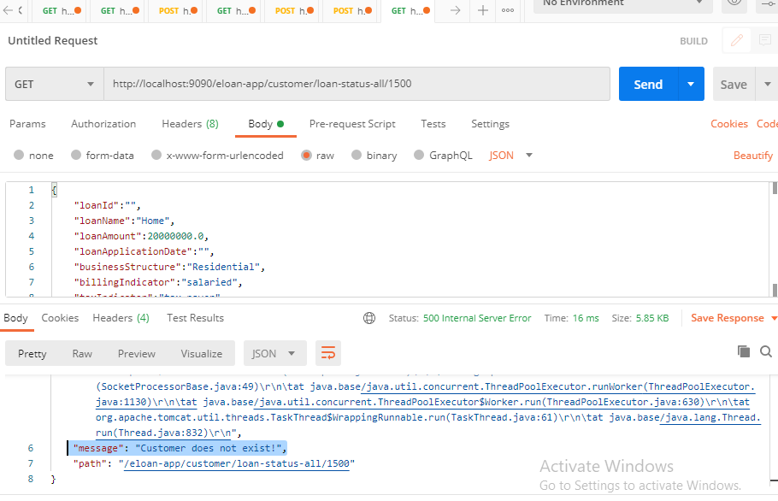

* While processing loan by loan clerk, if clerk id does not exist then operation should throw custom exception.

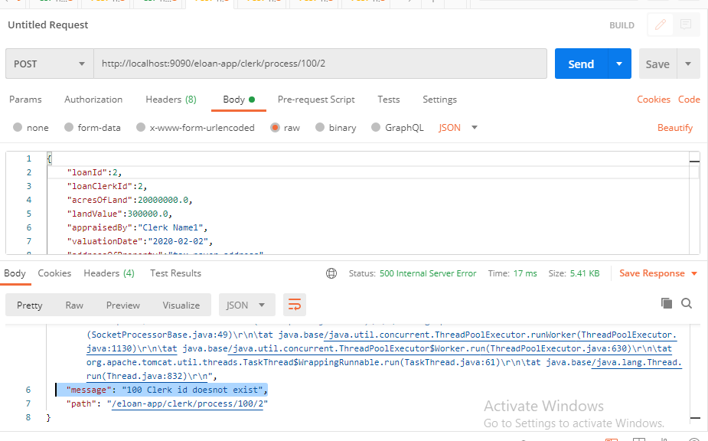

* While processing loan by loan clerk, if loan application id does not exist then operation should throw custom exception.

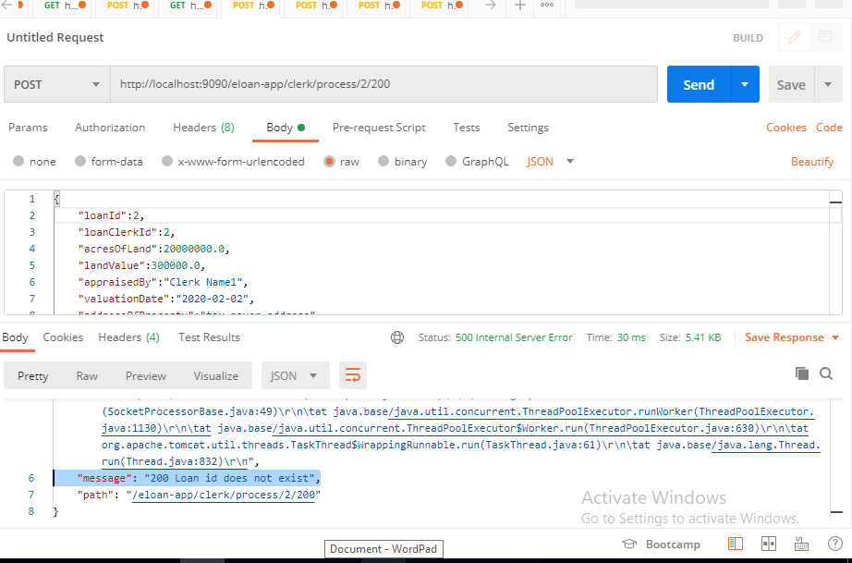

* While processing loan by loan clerk, if loan has already been processed then operation should throw custom exception.

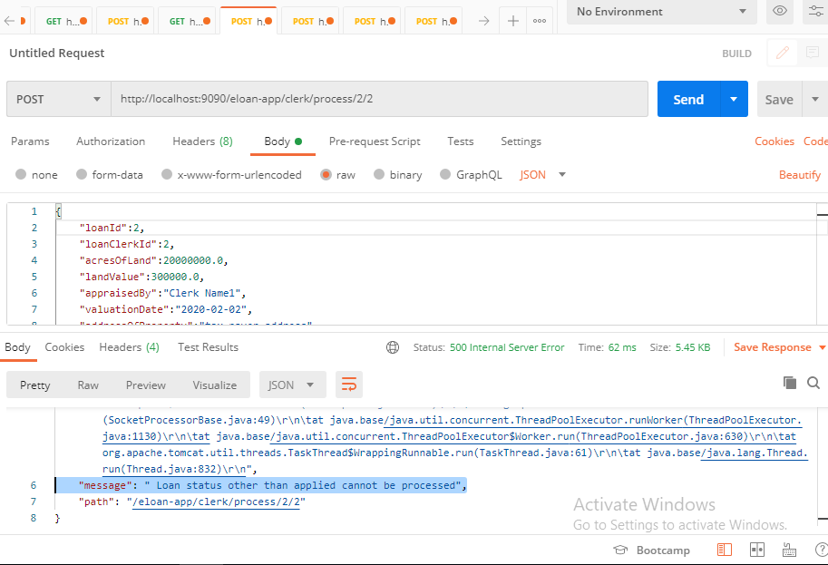

* While sanctioning or rejecting loan by manager, if manager id does not exist then operation should throw custom exception.

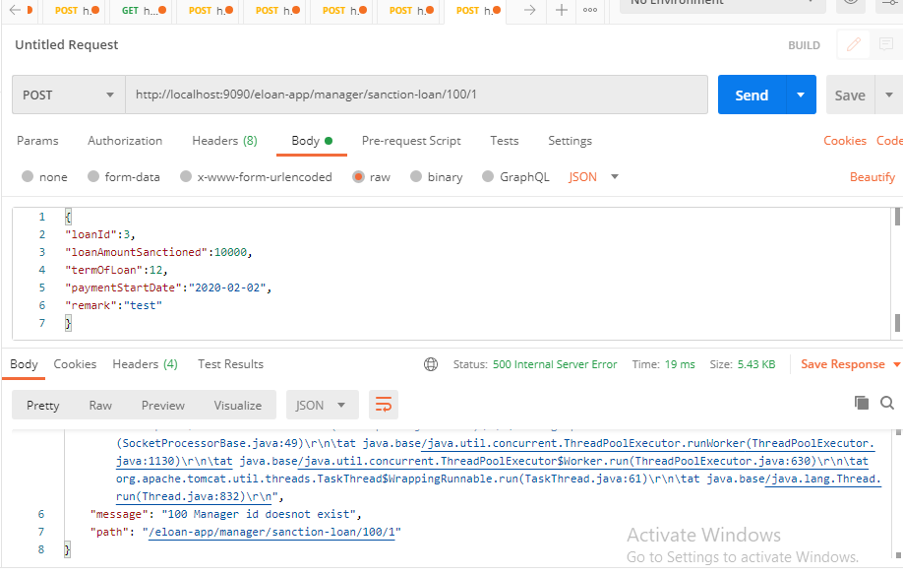

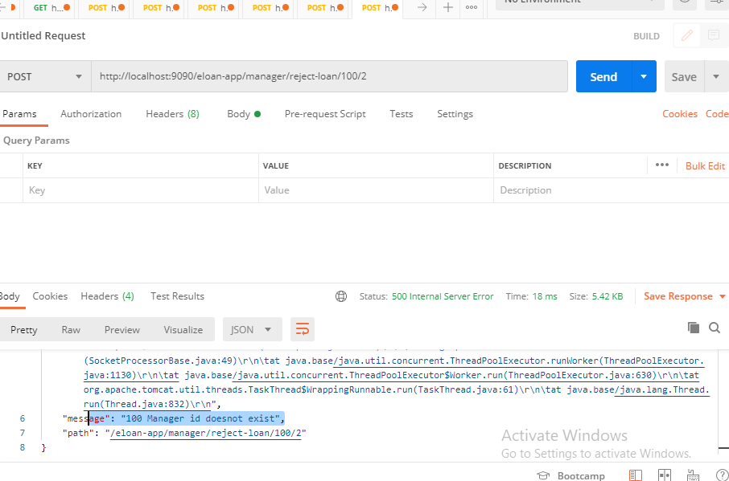

* While sanctioning or rejecting loan by manager, if loan application id does not exist then operation should throw custom exception.

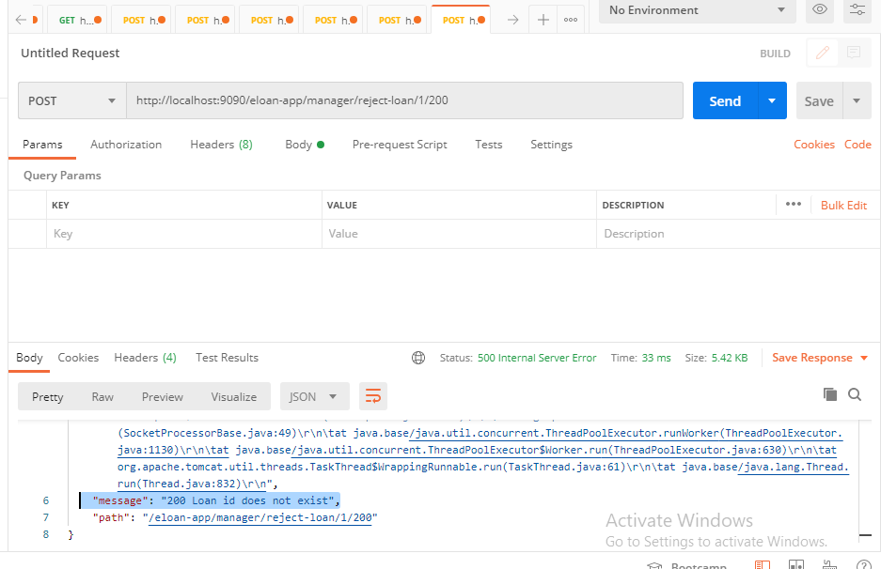

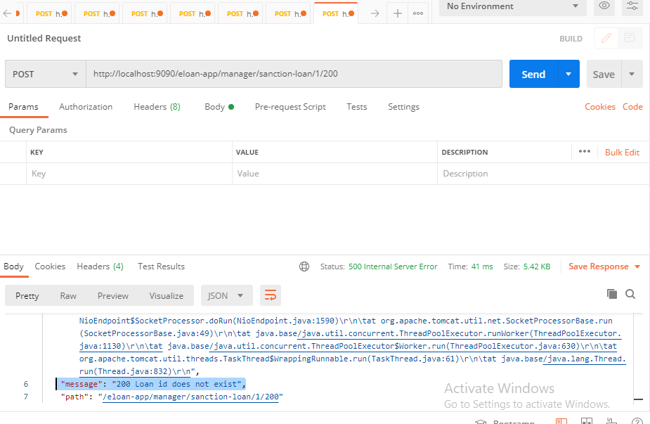

* While sanctioning or rejecting loan by manager, if loan has already been rejected or sanctioned then operation should throw custom exception.

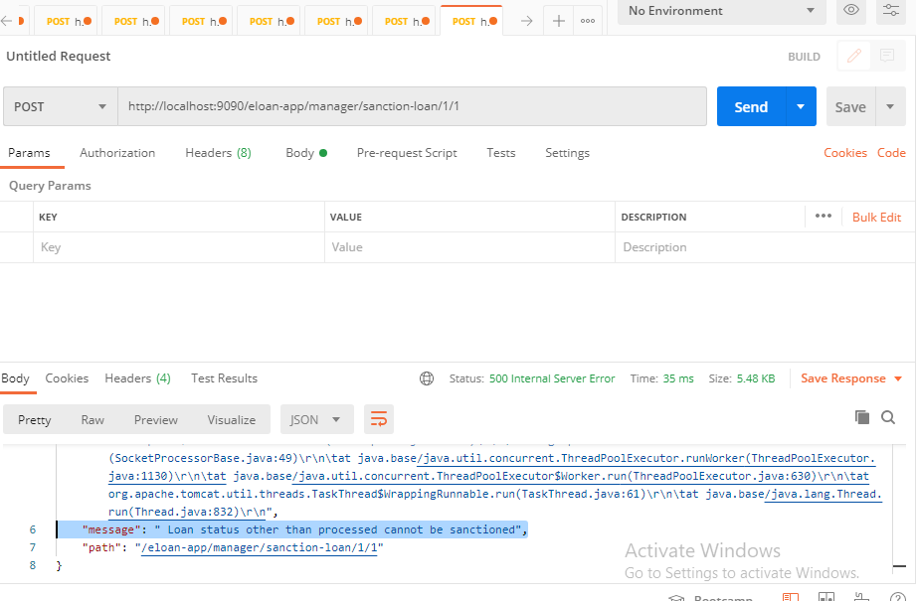

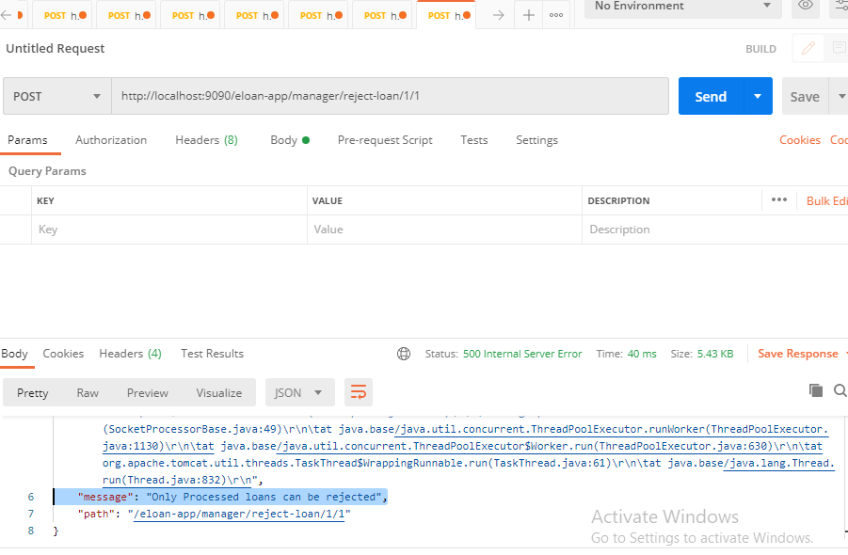

* For all rest endpoints receiving @RequestBody, validation check must be done and must throw custom exception if data is invalid

